LESSON 1 – LabVIEW “Hello World”

The LabVIEW version of a “Hello World” program is to make a piece of hardware do something basic, usually it is turning an LED On and Off.

Wire the hardware as shown
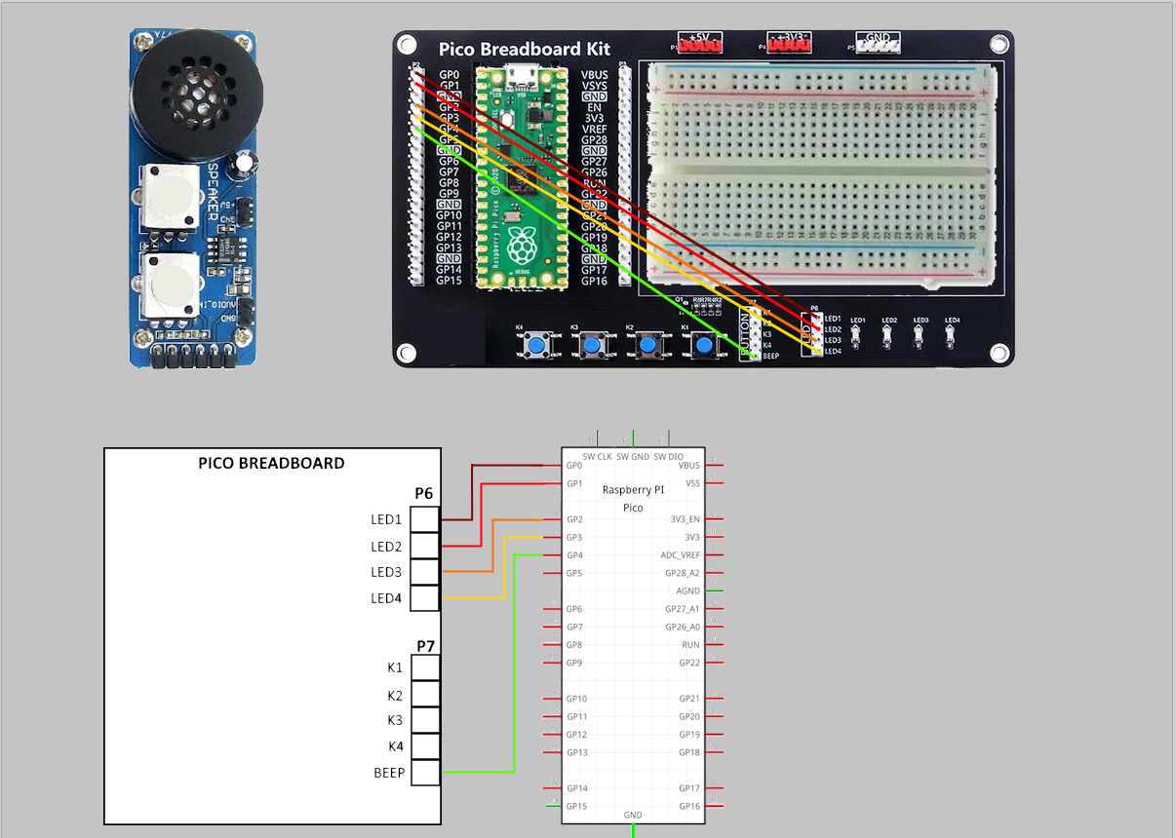
Make sure Pico is set-up correctly (see Course set-up instructions)
- Load LabVIEW.
- From LabVIEW select New VI
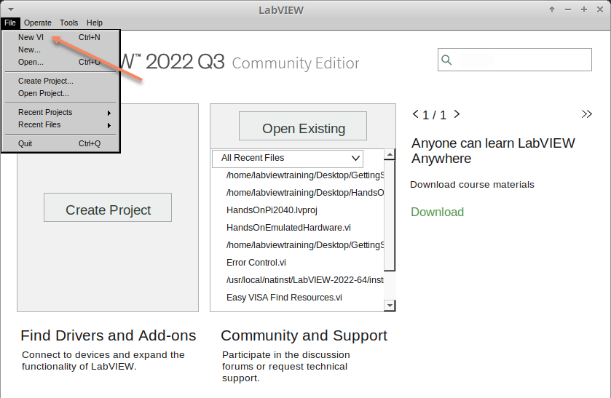

- Setup the screen like this:
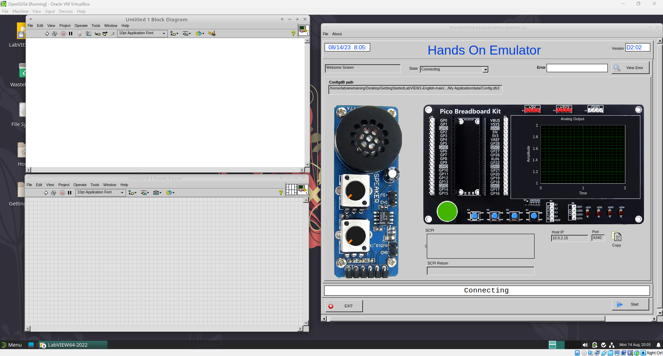

In LabVIEW a VI is a Virtual Instrument is equivalent to a function or module in other languages. A LabVIEW program is made up of 1 or more VIs.

- In the block diagram right-click and navigate to the HandsOnPi2040 Driver Palette.

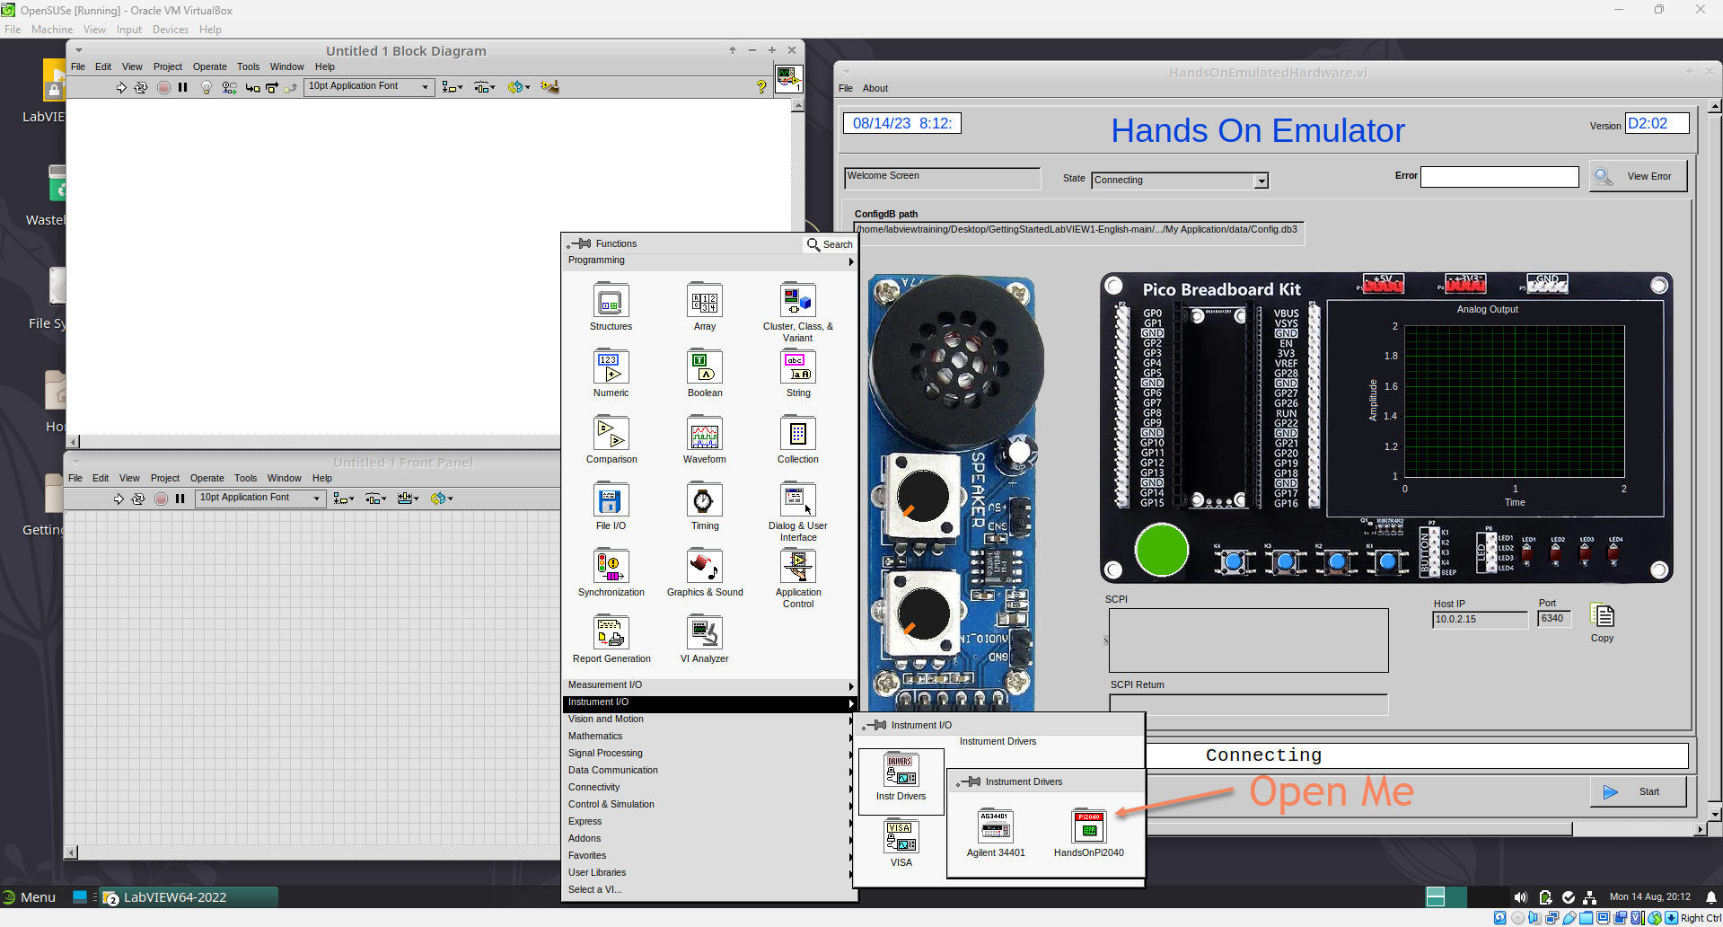
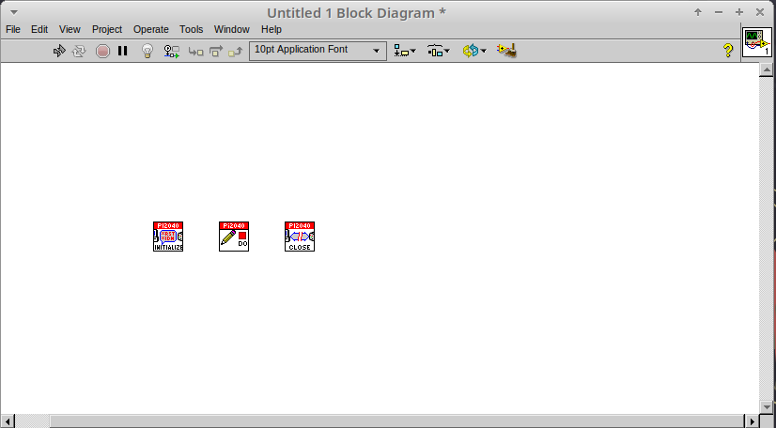
- Drag and drop Initialize.vi, WriteDO.vi and Close.vi onto the block diagram as shown below.

Notice that the Run-arrow is broken (the run arrow appears in the top left corner), if you press it, it will list all the reasons why it’s broken.

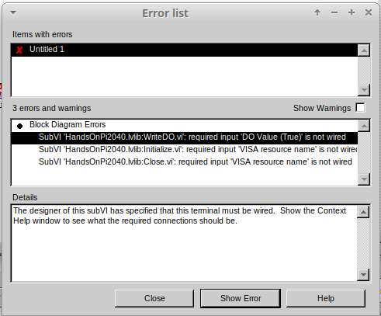
- LabVIEW will not let you run the source-code until these errors are sorted. Close the Error List and select all of the Vis. (Left-click drag on mouse).

- Press Ctrl+space to bring up quick drop and Ctrl+W to wire the VIs together. Quick drop is an extremely useful productivity tool that ships with LabVIEW. It allows you to automate repetitive tasks with a few key combos.

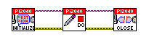
If you press the Run arrow now you will notice that there are only 2 issues listed, good job!

- Press Ctrl-H to bring up the context help window. Hover over Initialize.vi.

Notice that VISA resource name is bold. This means that it needs to have an input.

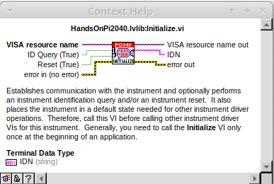

- Now, right-click on VISA Resource Name Initialize.vi and select create constant.

If you press the Run arrow now you will notice that there is only 1 issue left.

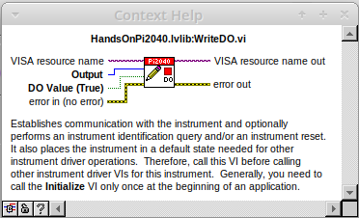
This VI needs it’s Output and DO Value (True) wiring. So let’s create constants for them. Use the arrow on the right to select an output.

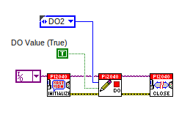
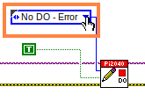

It’s nice to have the constant label shown for booleans.

- Right cllck on the ‘True’ Boolean Constant. This will bring up a drop down window, hover over ‘Visible Items’ and select ‘Label’.

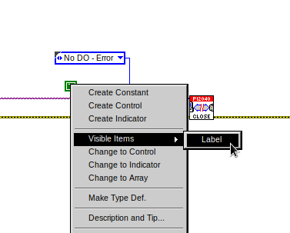

Constants are terminals on the block diagram that supply fixed data values to the diagram. We’ll discuss data types etc later in the session.

- Finally let’s wire in a couple of outputs.
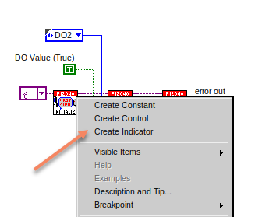

- Right-click on IDN for Initialize.vi and Select Create Indicator. Then we need an error out, so right click at the bottom the Close.vi and select Create Indicator.
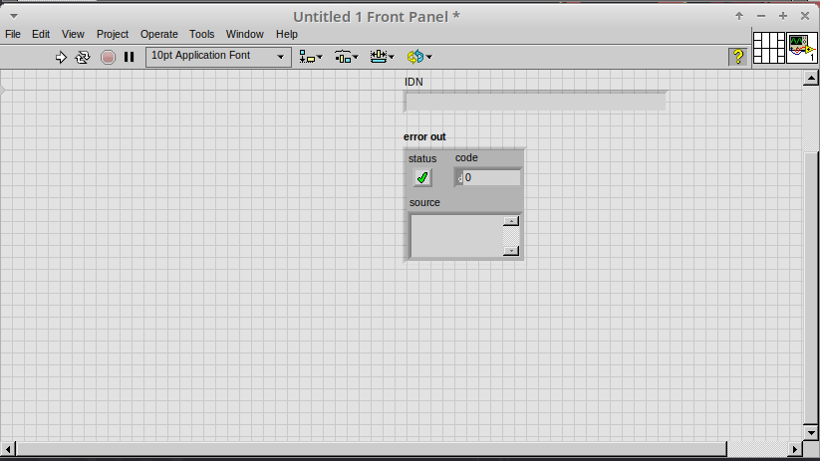

Notice how the Indicators appear on the Front Panel. We’ll discuss block-diagrams and front panels in a bit.

Now we have a running program!

Let’s run it….
Oh dear, we have an error.
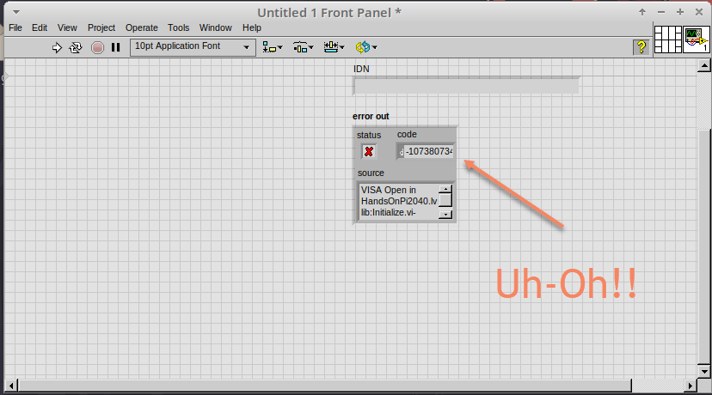

- We can interrogate the error message to try and get a clue as to why it all went so wrong. Sometimes it can even be helpful.

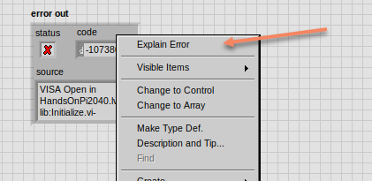

In this case it is!
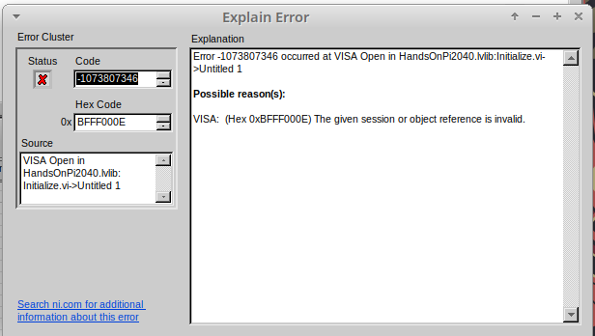
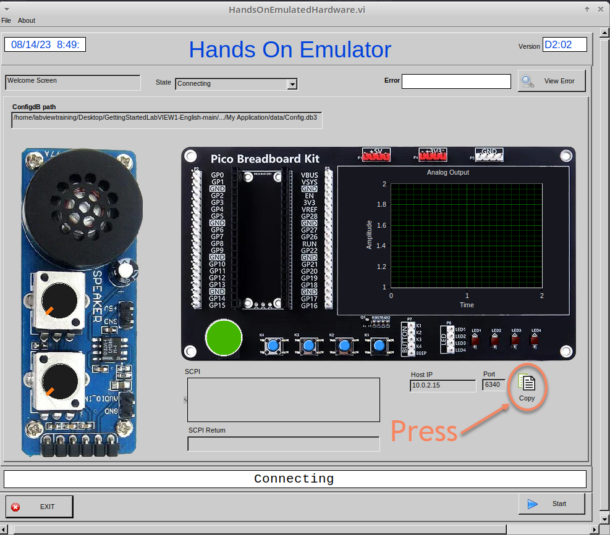
- The VIs don’t know who they are talking to. So go to the emulator and press the copy button, this will give the VISA resource name for the instrument.

- And then paste it into the VISA resource name in the block diagram.
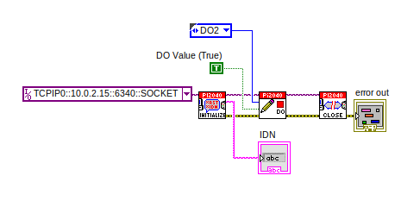

- Now press run again.

Here we can see that no errors were apparent and IDN has a value.
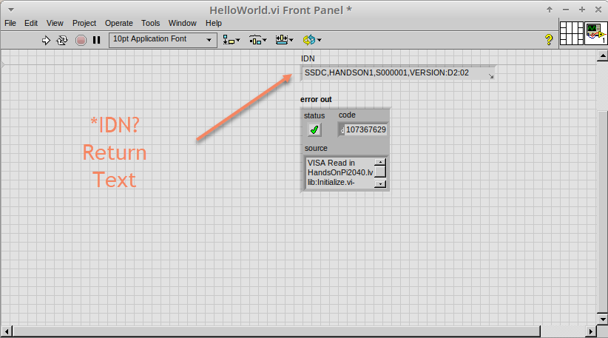

But more importantly the LED on the hardware has turned on.
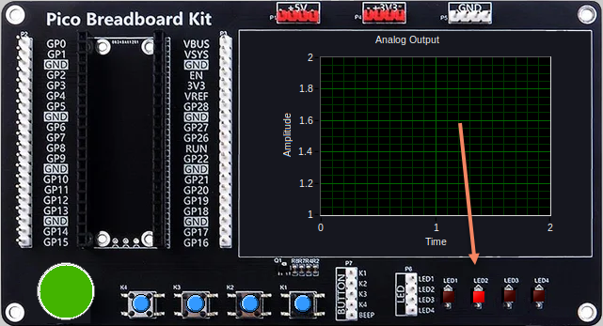
Lesson 2 – For Loops

FOR LOOPS

A For Loop executes a sub-diagram a set number of times. In this case we will learn how to build a program that will blink the previous LED on and off 10 times each and then stop.

- Make workspace bigger, allow for adding objects. Use Ctrl and drag to expand.

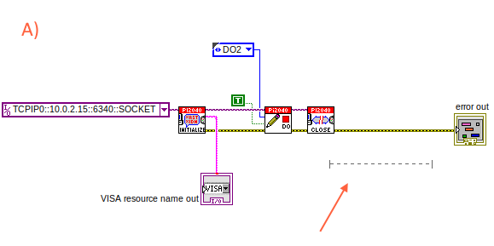
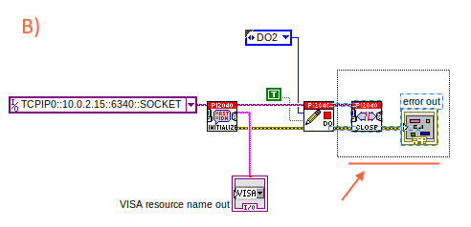

- Alternatively select the objects you need to move with the selection tool and drag them where you want with the mouse, or using the arrows.

Note: press shift with an arrow key to move selected items quicker.

- Now we need to insert a For Loop, to do this right click anywhere on the block diagram to bring up the functions palette. Select Structures and the For Loop.
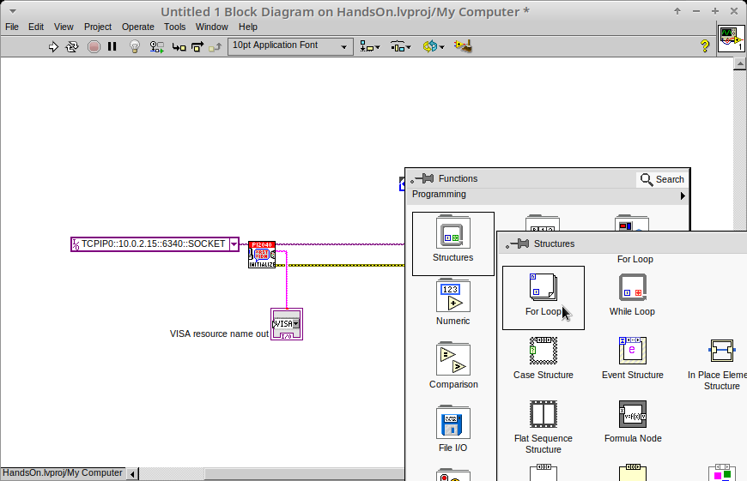

- We will only need to place the For Loop around the WriteDO SubVI (and the constants attached to it.)

- Once the For Loop has been placed, you will see an ‘N’ in the top left corner, this is the loop count (or how many times the loop will execute.)

- Right click on the left hand side of the Loop Count, and select Constant. For this task we will need the Loop Count to be 20 (10 times on and 10 times off.)
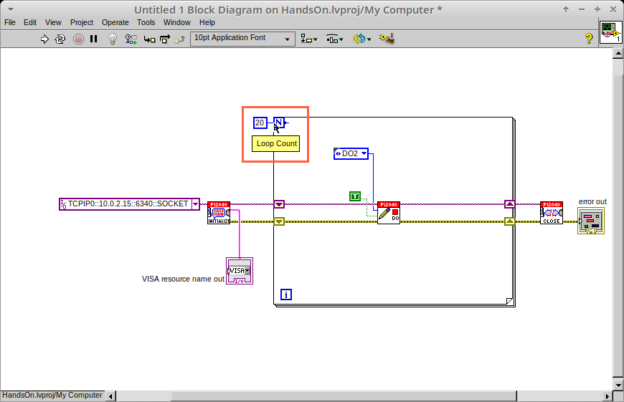

In order for the program to ‘blink’ successfully it will need to know what the previous loop had executed therefore you will need a Shift Register.

- Right click on the edge of the For Loop and select ‘Add Shift Register.’ Wire the ‘True’ Constant to the Shift Registers, and the DO (Value) tip strip.

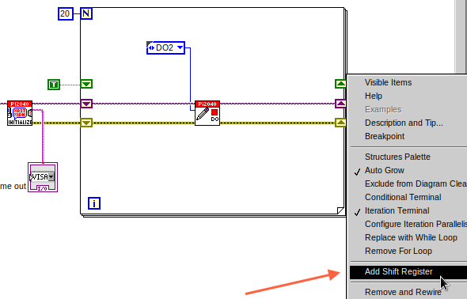
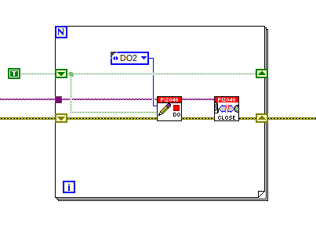

If you were to run the program at this point the LED would light up, but would not ‘blink.’

- For a blinking LED you will need to invert the boolean value after every loop. To do this right click anywhere to bring up the functions palette. Hover over ‘Boolean’ then select the ‘Not’ Boolean. Wire this into the shift registers.

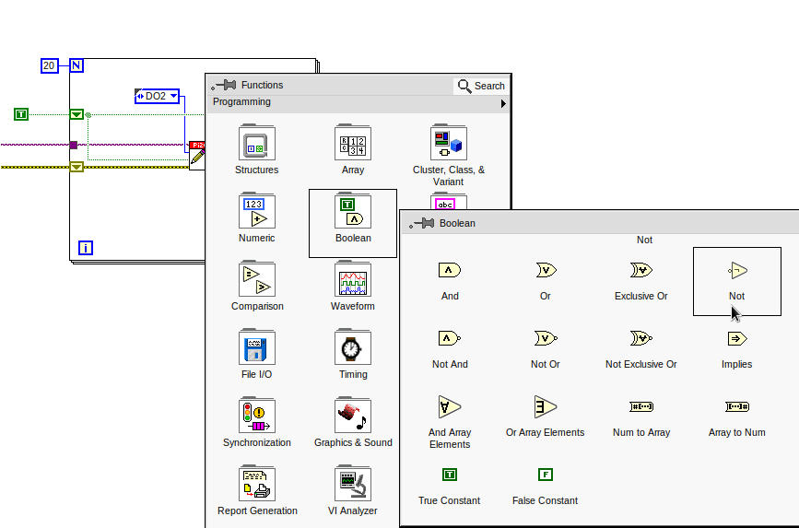

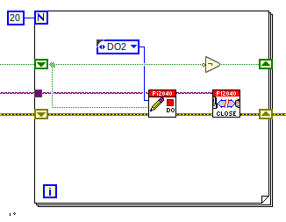

The program will now work! However, it will execute very fast, and you will not be able to see the LED blink. So you need to slow the Loop down.

- Right click inside the For Loop, hover over ‘Timing.’ There will see many different timing options. For this you will use the ‘Wait’ function. Select and place inside the Loop.

- Create a constant by right clicking on the left side of the ‘Wait’ function. The ‘Wait’ function executes in milliseconds, therefore to slow down the Loop by 5 seconds, write 500.
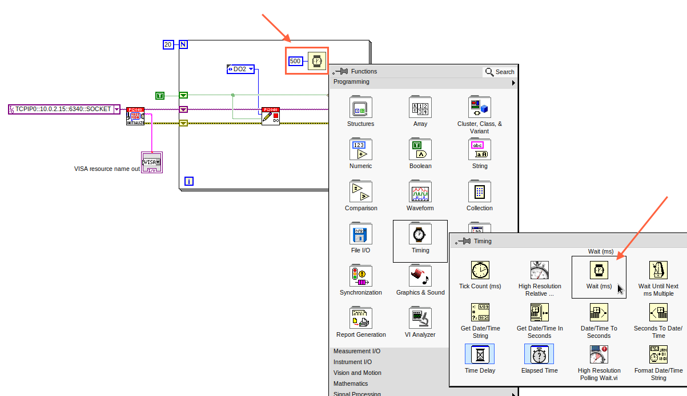

Lesson 3 – While Loops

WHILE LOOPS

The While Loop executes the sub-diagram until a specific condition occurs. It will always execute at least one time.

In this case, we want the LED to continually blink on and off until a ‘Stop’ button is pressed. We can create this using the previously built program with the For Loop.

- Firstly, right click on the edge of the For Loop, and select ‘Replace with While Loop’
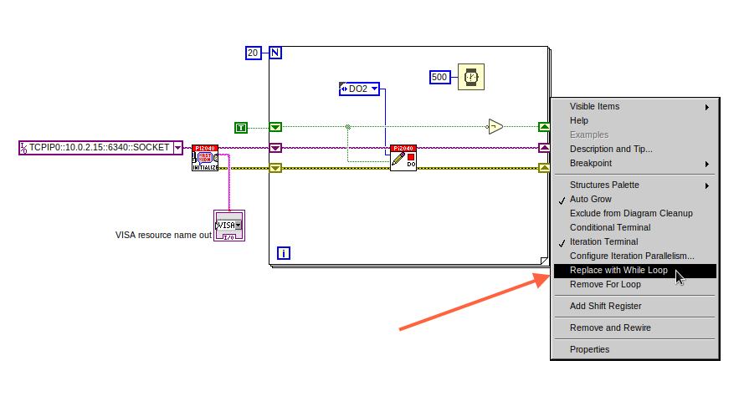

- Now the For Loop has been replaced, the Loop Count is not connected. This is not needed for a While Loop and can be deleted.

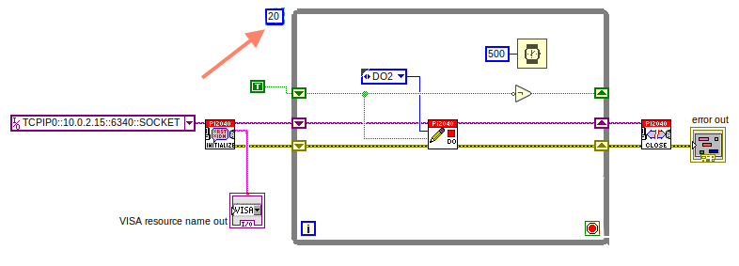

- To add a ‘Stop’ boolean, switch to the front panel window and right click where you want to place the button. The Controls palette will appear, select ‘Boolean’ and pick a button. The example uses a ‘Push Button’ but any will work.

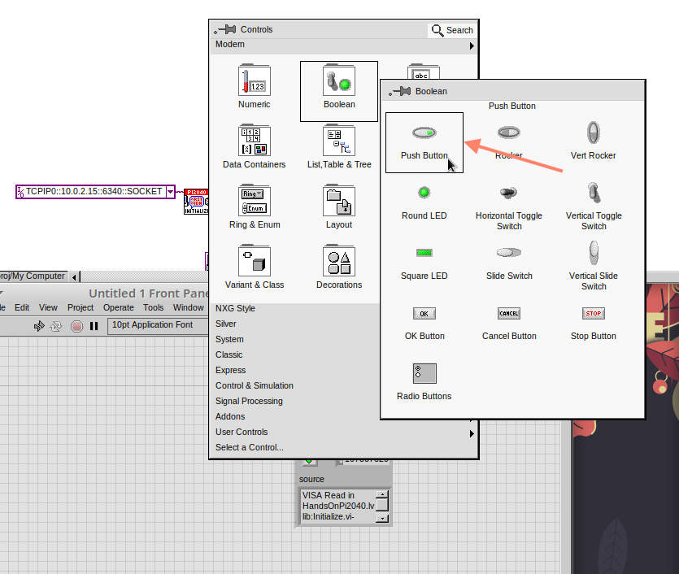

- Back on the Block Diagram move the new Control Boolean into the While Loop and wire it up to the Conditional Terminal in the bottom right corner. If the Button on the Front Panel is pressed when the program is running then the Loop will end and the ‘blinking’ LED will stop.

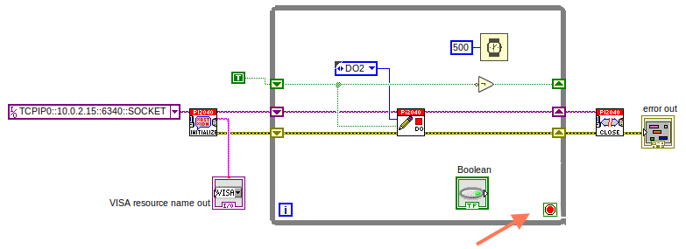

Lesson 4 – Event Structure

EVENT STRUCTURES

An Event Structure waits until an event occurs, then executes the appropriate case to handle that event. In this example, we want to press a buttons and the corresponding light to turn on.

We can use the previous While Loop program in this Event Structure. Firstly we need to remove some of the functions; the Shift Register, the Not Boolean, and the Timer are no longer needed.

Removing these will create a lot of broken wires. A quick way to clean this up is CTRL+B.

- Right click inside the While Loop to bring up the Functions Palette, select Structures and then Event Structure. Place the Structure around the central VI as this is what we will program to change.
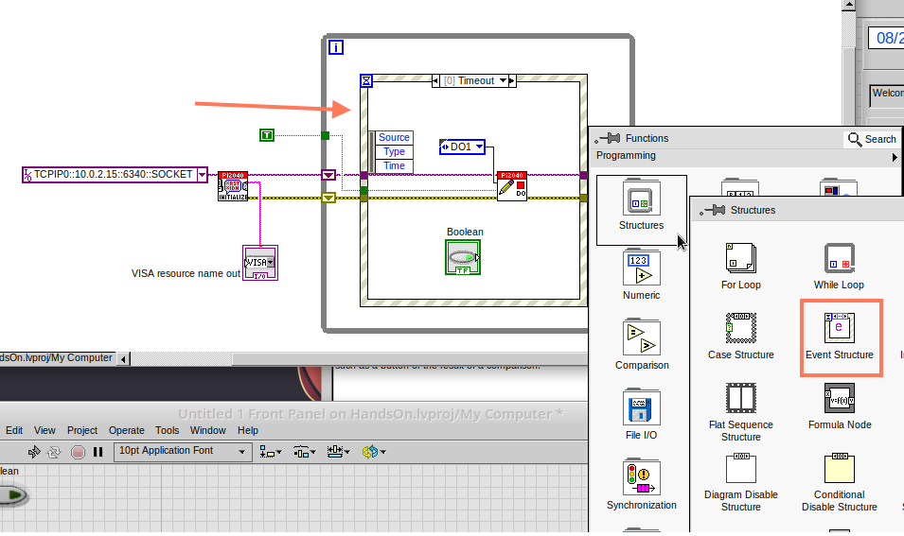

- It’s important to connect the Event Case to the Boolean. This will ensure that when the Boolean is pressed it will trigger the Event Case to execute. Right Click on the Selector Label, then select ‘Edit Events Handled by This Case.’
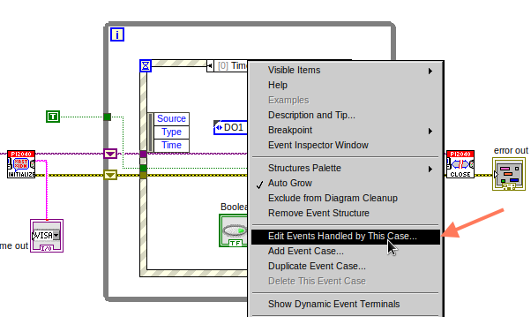

- This will bring up the following window. Select Boolean at the bottom of the ‘Event Source’ column.

Notice that under the ‘Events’ column it shows that the Event Structure will execute when there has been a value change if the Boolean.

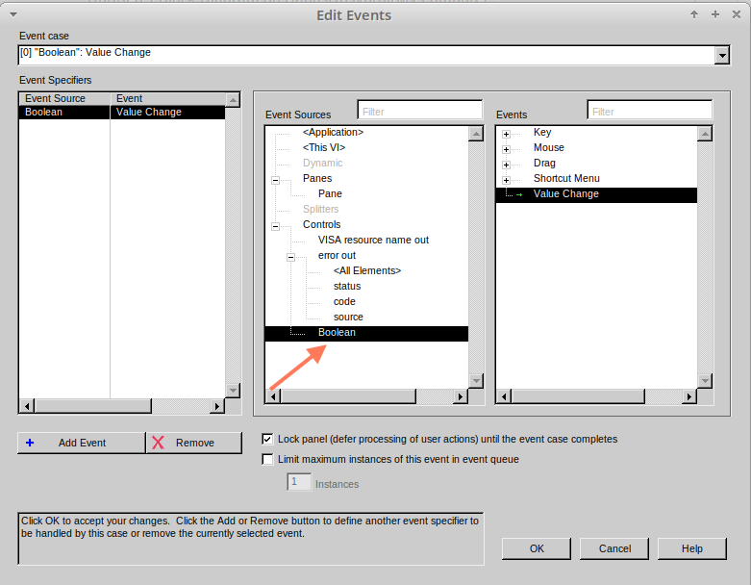

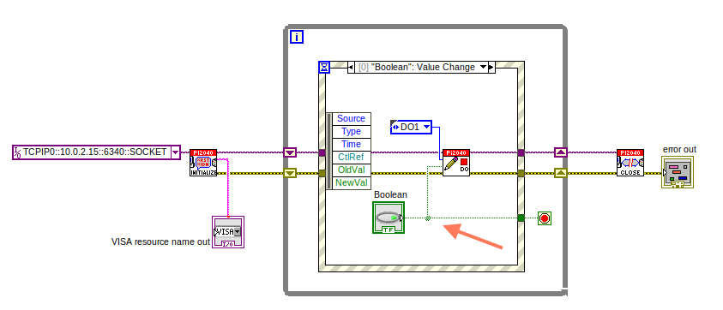

- You will no longer need the ‘True’ constant, remove it, and wire the boolean in its place. Connect the new Boolean to the ‘Loop Condition.’

- Each event in the Event Structure will be very similar, the only change will be the ‘DO’ Output. Right click the Selector Label at the top of the Event Structure and select ‘Duplicate Event Case.’
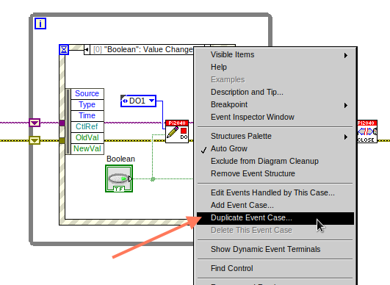

- As before this will bring up the ‘Edit Events’ window, however, this event case will execute with Boolean 2.
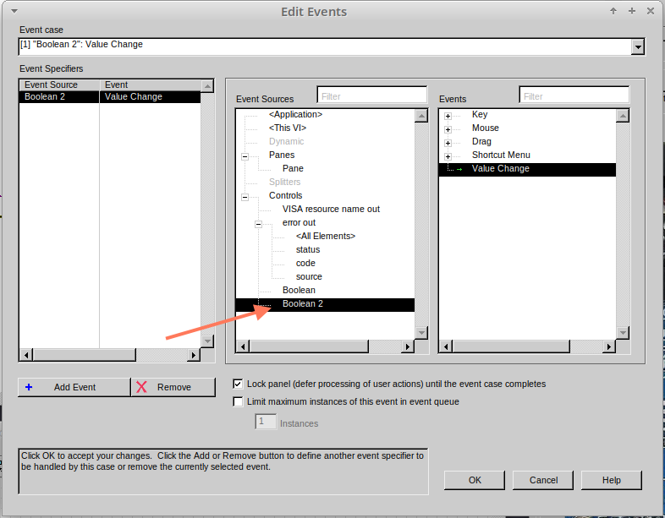

- Click on the drop down arrow on the Digital Output constant and select the corresponding output. In this case choose DO2.

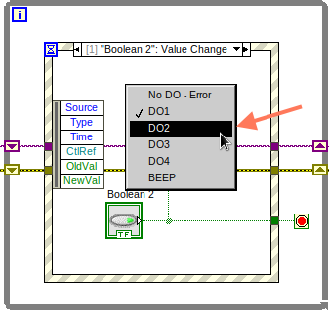

- Do these same steps 2 more times to create 4 Event Cases, and 4 Booleans (on the Front Panel.)

Note: Your Front Panel may look like the image below. Clean up the Front Panel so it is easier to use and read.

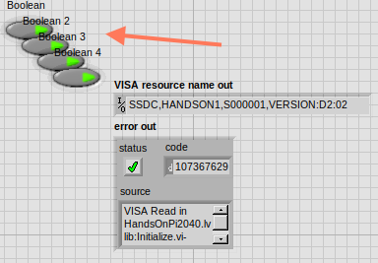
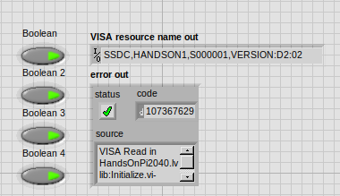

- At this point it is possible to run the program. When a button is pressed the corresponding LED will light up. However, it isn’t very efficient and will execute only once and the program will end.

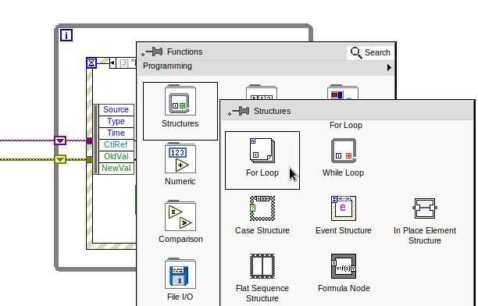
- A For Loop can defeat this problem. As before, right click for the Functions Palette, and select For Loop. Place around the While Loop.

- Finally you will need to create a constant for the Loop Count. Chose a number that allows you to test the program effectively.

e.g. a Loop Count of 1 will only execute once so you will not be able to test all the Outputs.

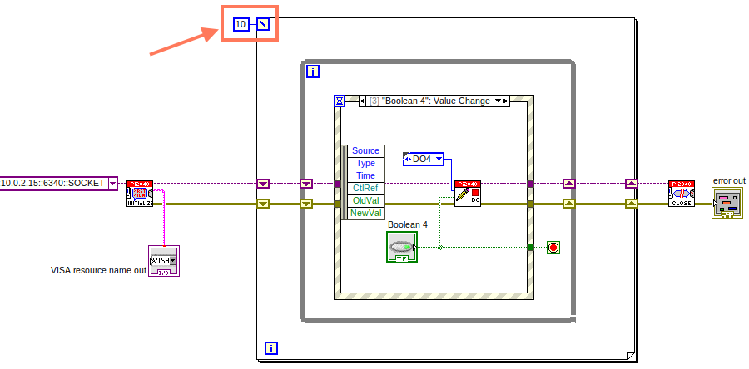

VIs (Virtual Instruments)

Programs in LabVIEW are called VIs (Virtual Instruments). In other programming languages a VI is similar to a function or a subroutine. A VI includes a Front Panel and a Block Diagram, the VIs Icon and its Connector Pane.

- Front Panel
The front panel window is the user interface for the VI. You create the window with controls and indicators, these are the interactive input and output terminals of the VI.

- Block Diagram
The Block Diagram is where you will create the code for your program. The block diagram will implement graphical representations of functions to control the objects on the front panel. Objects on the front panel will appear as terminals on the block diagram.

- Icons, Connector Panes, and SubVIs
The icon and connector pane allow you to use and view the VI in another VI. This is called a SubVI, to use a SubVI you must build a connector pane. Customising the Icon is recommended to help with reading and understanding the program.
  - The Icon is displayed in the upper right corner of the VI, it is a graphical representation of the VI. The icon can be customised with text and images to help identify what the VI does.
  - The connector pane is a set of terminals on the icon the corresponds to the controls and indicators of the VI.

Icon
Connector Pane
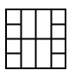
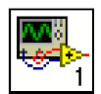

Data types

Each variable in a program must have a data type. The data types determines what type of value the variable will hold.

Numeric –
- Integer (int) – whole numbers (e.g., -700, 0, 700)
- Floating point (float) – numbers with fractions (decimals) (e.g., 700.0, 0.7)
Boolean – represents 2 states (e.g., true, or false, 1 or 0)
String – sequence of characters, digits, or symbols – always treated as text (e.g., hello)
Enumerated type – predefined unique values (can be text or numerical) (e.g., rock (0) jazz (1)
Character – a single letter, digit, punctuation mark, symbol, or blank space.
Array – stores multiple elements in a specific order.
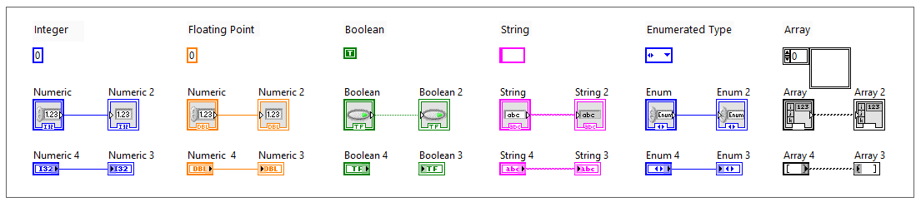
Note: right click on a data type terminal and select ‘View as Icon’ depending on your preference. (The 2nd row shows the terminals as icons.)

While Loops

While Loops allow portions of a program to execute repeatedly until a certain condition is met.
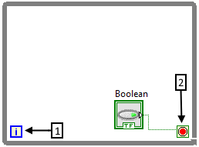

- Iteration Terminal – the iteration terminal provides the current loop iteration.

- Conditional Terminal – Evaluates a Boolean input value at the end of each loop iteration, if the conditional terminal is met then the loop stops.

For Loops

Executes a sub-diagram a certain number of times. This value is wired to the Count Terminal (N).
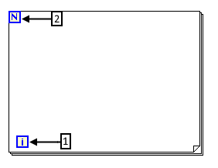

- Iteration Loop – Indicates the number of completed iterations.

- Count Terminal – Specifies the number of times to execute the code inside the For Loop.

Event Structures

An Event Structure waits until an event occurs, then executes the appropriate case to handle that event.

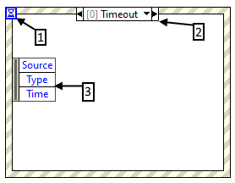

- The event selector label specifies which events cause the displayed case to execute.

- The Timeout terminals specifies the number of milliseconds to wait for an event before timing out.

- The Event Data Node identifies the data LabVIEW returns when an event occurs

